Money doesn't talk, it swears.
Bob Dylan
MONEY TALKS

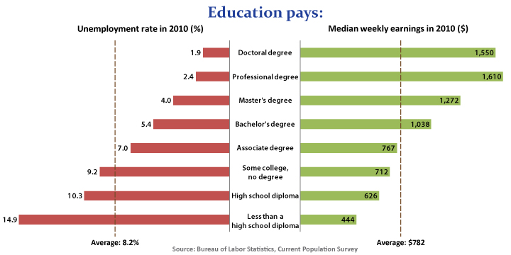
Financial Aid Updates
(Dept. of Education modifications)

- Lifetime Pell Eligibility: Students can only receive a full time Pell award for 6 years. Planning and progress toward degree is important.

- Pace of Completion: Students must complete at least 67% of their total attempted hours. Failure to do so has consequences.

- Developmental Courses: Financial aid will pay for 30 credit hours of developmental classes.

- Course Selection: Students must enroll in courses for the designated degree or certificate program.

Financial Aid Updates (Dept. of Education modifications)

- Lifetime Pell Eligibility: Students can only receive a full time Pell award for 6 years. Planning and progress toward degree is important.

- Pace of Completion: Students must complete at least 67% of their total attempted hours. Failure to do so has consequences.

- Developmental Courses: Financial aid will pay for 30 credit hours of developmental classes.

- Course Selection: Students must enroll in courses for the designated degree or certificate program.

2 Important Websites

www.FAFSA.gov Important First Step
- FAFSA = free application for federal student aid
- process for Federal aid (PELL)
- also process for State aid (MAP)
- often required for scholarships

www.prairiestate.edu go to PSC Foundation
- possible $$ help (tuition, fees, books)
- in-district requirement
- FAFSA requirement
- assistance rather than cover 100% of costs
- complete application; write two paragraphs

Information Needed for FAFSA

- Social Security Number (be sure it is correct)
- Records of Income (work, business, child support paid or received, other income)
- Information About Assets (cash, checking, savings, certificates of deposit, stock options, bonds, college savings programs, investment real estate, business and farm)
- Driver’s License Number (if have one)
- Date of Birth (include month, day, year)
- Month and year of marriage, separation, divorce or other change in marital status
- Alien Registration Number (if not a U.S. citizen)

